| AEPHY2024  **Narrogin SHS Year 11 ATAR PHYSICS Name:** |
| --- |

| Task No: | 6 |
| --- | --- |
| Task Type: | Test |
| Content: | Electrical circuits |
| Task Description: | Complete the attached questions in the spaces provided.  Marks will be awarded for presentation and working.  **Test conditions (50 minutes).**  *Formulae and data booklet provided.*  *Non-programmable calculator permitted* |
| Total Marks: | 35 |
| Weighting: | 6% |
| Materials required | pens, pencils (including coloured), sharpener, correction fluid, eraser, ruler, highlighters, scientific calculator |
| Due Date: |  |

1. Calculate the total resistance for each of the following circuits.

a.

10Ω 15Ω

RT = ______

20Ω

b.

20Ω 35Ω

RT = ______

(2 marks)

1. For the following circuit, calculate the voltage across each resistor and the current flowing through each resistor.

12V

10Ω

I = _____

V = _____

12Ω

I = _____

V = _____

(4 marks)

1. For the following circuit, calculate the voltage across each resistor and the current flowing through each resistor.

24V

15Ω 20Ω 30Ω

I = ____ I = ____ I = ____

V = ____ V = ____ V = ____

(3 marks)

1. For the following circuit, calculate the voltage across each resistor, the current flowing through each resistor and the total power of the circuit.

100V

200Ω

I = ___ 300Ω 400Ω

V = ___ I = ____ I = ____

V = ____ V = ____

P= ____

(7 marks)

1. Motor vehicles have combined tail lights and brake lights that contain two separate filaments in the one globe. The tail light filament has a resistance of 9Ω and the brake light filament has a resistance of 18Ω.

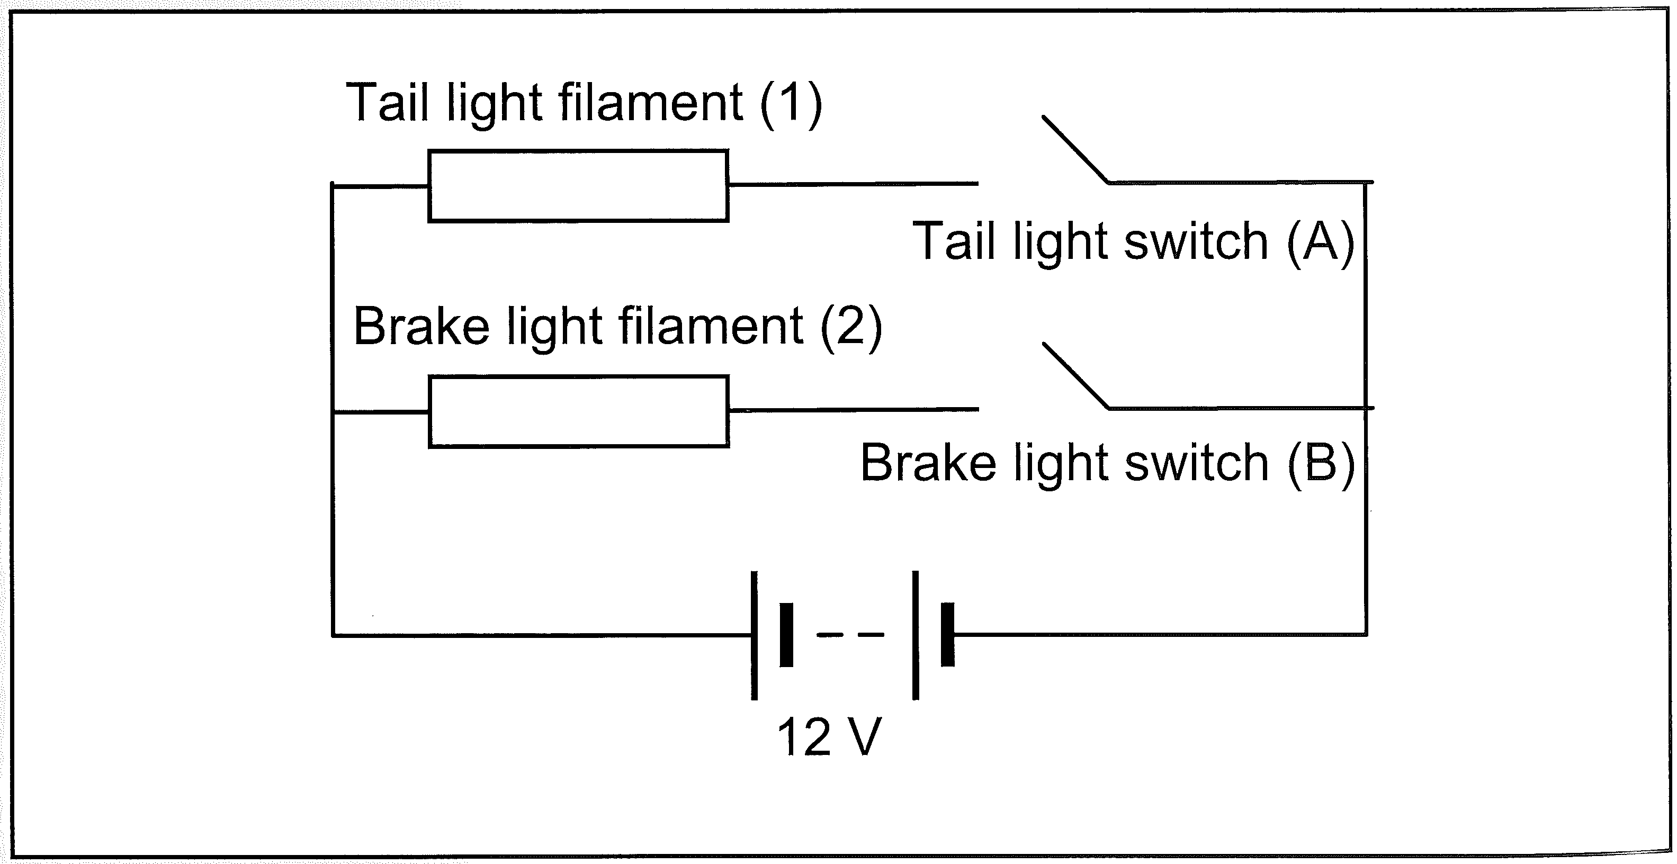

1. Why are the filaments connected in parallel?

(1 mark)

1. Calculate the overall resistance of the lamp when both switches are closed.

(2 marks)

1. Calculate the total current supplied by the 12V battery when both switches are closed.

(2 marks)

1. Calculate the total power consumption of the lamp when both switches are closed.

(2 marks)

1. Does the power consumption of the tail light filament change when the brake light is switched on? Explain.

(2 marks)

1. A student is building a fridge alarm using a do-it-yourself electronics kit. The kit requires a 20Ω resistor, but the resistor is missing. The kit contains two 5Ω resistors, one 10Ω resistor and two 30Ω resistors. Show two different ways that the available resistors could be used to substitute the missing resistor.

(4 marks)

1. Explain the difference between an ohmic and a non-ohmic resistor.

(2 marks)

1. Electricity supplies in WA often experience ‘power surges’ when the voltage suddenly increases to well over 240V for a short period of time. These surges often blow fuses, but do not cause RCD switches to shut off. Briefly explain how fuses and RCD switches work and why power surges affect them differently.

(4 marks)

End of Test